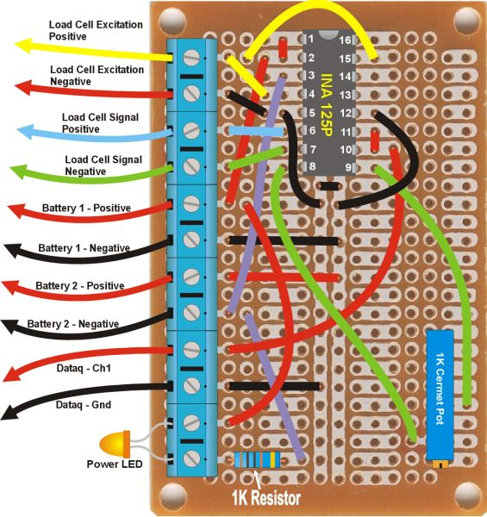
1
2
3
4
5
6
7
8
9
10
11
12
INA 125 Amplifier By Blunt Instruments Inc.
Pin 15 is for 5 volt excitation. Use this with the single battery clip(s)
Pin 16 is for 10 volt excitation. If you use the double-battery clips, move the yellow wire to here.
Beware that you must have a power supply of 11.25 volts or higher to make good use of this pin right. One 9v doesn’t cut it.
This amp can be operated with a single 9v battery, two 9v batteries, or four 9v batteries.
Generally rule - the more batteries used, the better it works. But that depends on your application.

It comes set up to operate from one 9v battery, with a single battery connector on terminals 5 and 6, and a short loop of wire connecting terminals 7 and 8. This configuration provides 5-volt excitation current, and positive-only load cell reading. Readings will not go below zero, into the negative. Also, the load cell reading will not go all the way to zero with a single battery, there will be a small bleed-through current. But your data acquisition software should take care of the bleed-through current that by setting the “low calibration” limit to zero.
Another single battery clip is provided. This can be connected to terminals 7 and 8 instead of the wire loop, to allow for negative readings. This may be irrelevant to your test stand, but the capability is provided here anyway as it might be needed for some instruments. It also helps in trouble-shooting, in case you hook something up backwards.
Double battery clips are also provided, each hooking two 9v batteries in series for a total of 18 volts or so. This allows use of the 10 volt excitation current, which provides better dynamic range and results in better resolution. You can use one pair of batteries on terminals 5 and 6, leaving the wire loop in 7 and 8 for positive-only readings. Or you can put four batteries to get 10v excitation and both positive and negative readings.
The cermet pot has been relocated, and the adjustment screw is now vertical for easier access. There are two test loops near the pot, so that its resistance can be easily checked with a meter and set to a precise value. Beware that you must unhook the load cell and batteries for this reading to be accurate.
Jimmy Yawn – jyawn@sfcc.net – 4/15/08

Note that I’ve added two decoupling capacitors to reduce interference from a noisy power supply. They do not appear on this drawing, but they are over here somewhere. And they might be irrelevant if you continue to use batteries.

